EENG 385 - Electronic Devices and Circuits

Audio Board: Amplifier Theory

Lab Handout

# Outcome and Objectives

The outcome of this lab is to determining the input resistance, gain and output resistance of the two stages in the audio amplifier. Through this process you will achieve the following learning objectives:

* Perform a DC and AC analysis of a circuit containing BJT.
* Analyze and design a circuit containing one or more BJTs.
* Analyze and design a circuit consisting of several building blocks.

# Audio Amplifier

The heart of the Audio Amplifier is shown in the schematic shown in Figure 1.

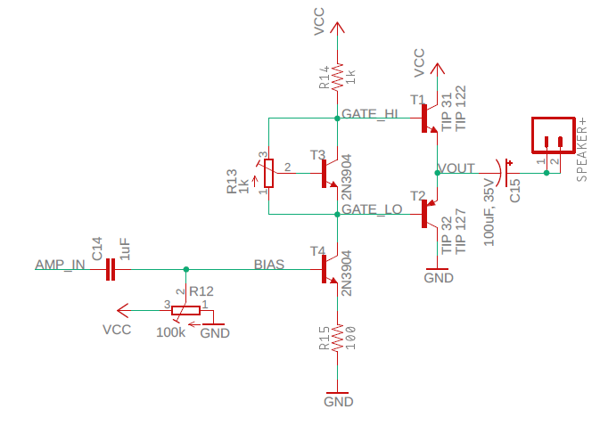

Figure : The core of the audio amplifier consists of a voltage gain stage followed by a current gain stage.

The output stage consists of a pair transistors T1 and T2 each in the common collector configuration. In the configuration shown in Figure 1:

* The base of T1 is 0.7V *above* the emitter.
* The base of T2 is 0.7V *below* the emitter

When an NPN and PNP transistor are arranged as shown in Figure 1, they are said to form a push/pull pair. The term alludes to the manner in which the pair pull the speaker towards VCC or push it towards GND. When we analyze the individual transistors in the push/pull pair, we will refer to them as emitter followers. The output of the push/pull pair should be centered at Vcc/2 = 4.5V so that the output voltage can swing as far as possible before hitting either rail.

Compute the emitter follower base voltages as follows:

1. In order for the output of the push/pull pair be 4.5V, what should you set the base voltage of transistor T1 to?

**In order for the output of the push/pull pair be 4.5V, the base of T1 must sit 0.7V above its emitter. This setting would make the base voltage 4.5V + 0.7V = 5.2V.**

1. In order for the output of the push/pull pair be 4.5V, what should you set the base voltage of transistor T2 to?

**In order for the output of the push/pull pair be 4.5V, the base of T2 must sit 0.7V below its emitter. This setting would make the base voltage 4.5V - 0.7V = 3.8V.**

1. What is the voltage difference between the voltages found in Questions 1 and 2?

**The voltage drop is 5.2V – 3.8V = 1.4V.**

# Common Emitter Theory

Transistor T4 in Figure 2 is configured as a common emitter. The base of T4 is the input and the collector is the output. Both the input and output voltages are measured with respect to the emitter terminal. Thus, the emitter is in common with both the base and the collector.

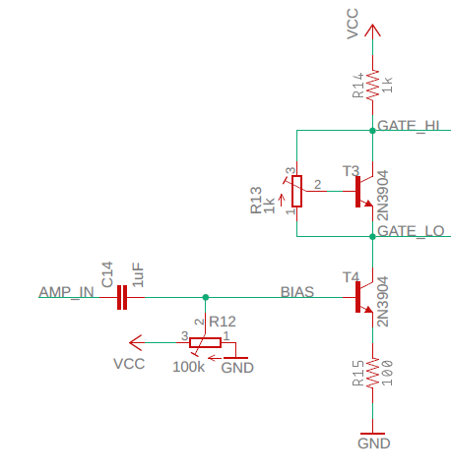

Figure : The common emitter stage of the audio amplifier.

The AMP_IN signal in Figure 2 comes from our audio source (that is, your phone or computer). Capacitor C14 removes the DC component from the audio signal and passes along an AC signal centered at 0V. The audio signal output of the capacitor is added (via superposition) to the bias voltage supplied by the potentiometer. You need to adjust the bias voltage so that the bases of the push/pull pair are set to the voltages you calculated in Questions 1 and 2 above. In other words, in the absence of an AC signal source, you need to:

* Set GATE_LO to 3.8V.
* Set GATE_HI to 5.2V.

Now you will use this information to adjust the bias voltage of the common emitter stage.

Compute the common emitter bias voltage as follows:

1. Find *IC* (the current through R14) so that GATE_HI is 5.2V where *VCC* = 9V**IC = (9V – 5.2V) / 1 kΩ = 3.8 mA**
2. Find *VE* assuming that IE is equal to IC

***VE* = 3.3 mA * 100 = 380 mV**

1. Find VB (your value should be close 1V).

***VB* = 0.33V + 0.7V = 1.08V**

# The Vbe Multiplier

The preceding section should have made it clear that the base of the two output transistors T1 and T2 in Figure 1 need to be 1.4V apart. The function is performed by the transistor T3 and the potentiometer R1called out in left-side of Figure 3. This circuit is called a Vbe multiplier for reasons that we will now explore.

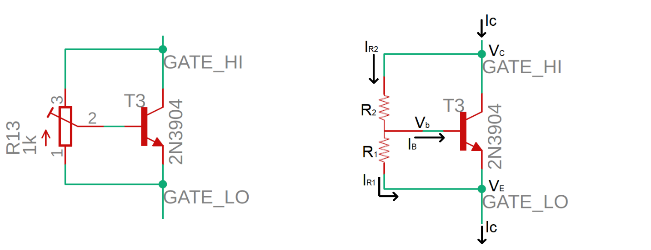

Figure : (left) The Vbe multiplier circuit used in our Audio amplifier. (right) The circuit used in the analysis.

Look at the left circuit Figure 3; adjusting the potentiometer R13 moves the center tap of the potentiometer along a 1kΩ track of resistive carbon film connecting terminals 1,3. If the center tap is moved closer to terminal 1 then the resistance between terminals 1,2 decreases and the resistance between terminals 2,3 increases. Thus, the sum of the resistance between terminals 1,2 plus the resistance between terminals 2,3 adds to 1kΩ.

You will use the circuit shown in the right side of Figure 3 to analyze the Vbe multiplier. Note that the potentiometer is replaced with a pair of resistors so that R1 + R2 = 1kΩ.

1. From the previous section, what is the current IC?

**IC = 3.8mA**

Assume that the BJT in Figure 3 is in the active region and that ß = 100,

1. What is IB for this value of IC?

**IB = 3.8mA / 100 = 38uA**

1. Write an equation for the current IR1 in terms of VBE and R1.

**IR2 = VBE/R1**

1. Assume that the center tap of the potentiometer is halfway so that R1 = R2 and VBE = 0.7V. What is the current IR1 equal to?

**IR1 = 0.7V/500Ω = 1.4mA = 1,400uS**

1. In this case, how much larger is IR1 than IB? Compute this as the ratio IR1/IB.

**IR1/IB = 1,400uA/38uA = 36.8 so IR1 is 36.8 times larger than IB**

1. Write a KCL equation for the VB node.

**IR2 = IR1 + IB**

1. Since IR1 is a lot larger than IB, rewrite this KCL assuming that IB = 0.

**IR2 = IR1**

1. Write an equation for VCB in terms of IR2 and R2.

**VCB = IR2 * R2**

1. Replace the IR2 term in the previous step with the equation in step 3

**VCB = VBE * R2/R1**

1. Write an equation for VCE in terms of VCB and VBE.

**VCE = VCB + VBE**

1. Replace the VCB term in the previous step using the equation in part 9

**VCE = VBE * R2/R1 + VBE**

1. Factor out the VBE term in the previous step.

**VCE = VBE (1+ R2/R1)**

This final equation shows that VCE is VBE times some factor. In other words, VBE is multiplied by a factor to get VCE. Hence the name, Vbe multiplier.

Now let’s dig into the amplifier using the framework shown in Figure 4. This figure is an abstract version of Figure 1 for small AC signals. It describes how the signal is mathematically manipulated. The Source is the audio input that you are providing.

The blue area labeled Common Emitter in Figure 4 is the circuit shown in Figure 2. Let’s look at this stage in the overall circuit shown in Figure 1. The input to this stage, Vce is the voltage at the base of transistor T4 in Figure 1, the BIAS test point on the PCB. The output of the Common Emitter stage is the collector of transistor T4 in Figure 1, the GATE_LO test point.

The blue area labeled Emitter Follower in Figure 4 is the circuit shown in Figure 6. Let’s look at this stage in the overall circuit shown in Figure 1. The input to this stage, Vef is the voltage at the base of transistor T2 in Figure 1, the GATE_LO test point. The output from this stage is the emitter of transistor T2 in Figure 1, the VOUT test point.

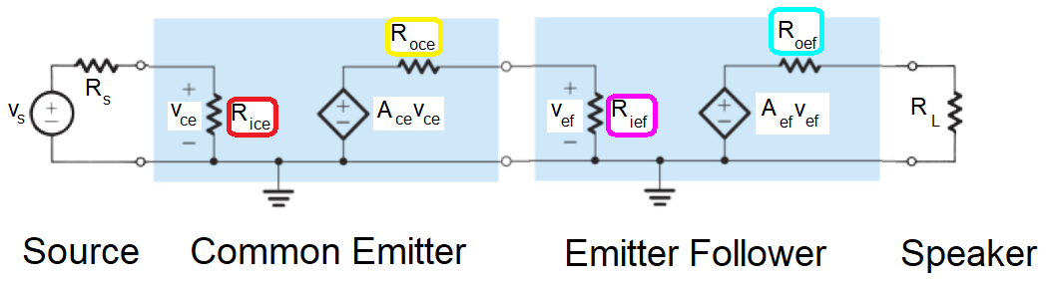

Figure : The small signal model of the Audio board. The input signal goes through a common emitter to amplify the voltage and then into an emitter follower to amplify the current before being sent out to the speakers.

Your task is to assign equations and values to the variables in Figure 4 and put them into Table 1. This information is critical in understanding how to improve the quality of the audio output.

Table : Model parameters for the cascade amplifier shown in Figure 4.

|  |  |  |  |
| --- | --- | --- | --- |
|  | ***Rin*** | ***Rout*** | **Voltage Gain** |
| **Source** | N/A | *Rs = 10Ω* | N/A |
| **Common Emitter** | *Rice =* | *Roce =* | *Ace =* |
| **Emitter Follower** | *Rief =* | *Roef =* | *Aef =* |
| **Speaker** | *RL = 8Ω* |  |  |

Let’s start by analyzing the common emitter amplifier from Figure 2, but in the more reduced form shown in Figure 5. Note the Vbe multiplier has been remove from Figure 2 and replaced by a wire. This is an acceptable substitution because we are interested in the behavior of the common emitter BJT, not the Vbe multiplier.

In this analysis you are frequently going to be asked to find the change in voltage of a node. A change in a voltage is not the same thing as the value of the voltage. For example, if I asked you to describe the relationship between the change in the emitter voltage (*ΔVE* ) in Figure 5 and the change in emitter current (*ΔIE*), you could use Ohm’s law to write:

*ΔVE = R ΔIE*

If you were then asked to solve this equation for *ΔIE*, you would write:

*ΔIE = ΔVE/R*

The steps in the derivations are numbers. Occasionally you will need to use an equation derived in a previous step to move the derivation forwards. When doing this, look for equivalent variables in the two steps, you will probably either substitute one equation into another or set two equations equal.

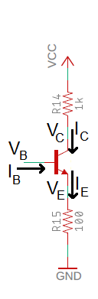

Figure : A simplified version of the common emitter shown in Figure 2.

**Compute the input impedance of the common emitter stage - *Rice*.** You will need to reference Figure 2 during this analysis.

1. What is the relationship between *ΔVB* and *ΔVE*?

***ΔVB = ΔVE***

1. Use Ohm’s law to describe the relationship between *ΔVE* and *ΔIE*.

***ΔVE = ΔIE * 100Ω***

1. Solve the previous equation for ΔIE and replace *ΔVE* with *ΔVB* from Equation 1.

***ΔIE = ΔVE / 100Ω ΔIE = ΔVB / 100Ω***

1. Write down the relationship between *ΔIE* and *ΔIB*? *(Hint, it is a bad parameter.)*

***ΔIE = βΔIB***

1. Equate the equations from step 3 and 4 using *ΔIE*.

***ΔVB / 100Ω = βΔIB***

1. Solve equation from step 5 for *ΔVB / ΔIB*, this is the input impedance of the common emitter. Insert this value into the *Rice* cell of Table 1.

***Rice = ΔVB / ΔIB = β 100Ω***

**Compute the output impedance of the common emitter stage -** *Roce***.** You will need to reference Figure 5 during this analysis.

1. Use Ohm’s law to describe the relationship between *ΔVC* and *ΔIC*.

***ΔVC = ΔIC * 1000Ω***

1. Solve Equation 1 for *ΔVC/ΔIC*. This value is the output impedance of the common emitter. Insert this value into the *Roce* cell of Table 1.

***Roce = ΔVC / ΔIC = 1000Ω***

**Compute the gain of the common emitter stage - *Ace*.** You will need to reference Figure 2 during this analysis.

1. What is the relationship between *ΔVB* and *ΔVE*?

***ΔVB = ΔVE***

1. Use Ohm’s law to describe the relationship between *ΔVE* and *ΔIE*.

***ΔVE = ΔIE * 100Ω***

1. Solve the previous equation for *ΔIE*.

***ΔIE = ΔVE / 100Ω***

1. Replace *ΔVE* in the equation from step 3 with the relationship found in the equation from step 1.

***ΔIE = ΔVB / 100Ω***

1. Use Ohm’s law to describe the relationship between *ΔVC* and *ΔIC*. Note the sign!

***ΔVC = -ΔIC * 1000Ω***

1. Since *ΔIE = ΔIC*, replace *ΔIC* in the previous step with *ΔIE*.

***ΔVC = -ΔIE * 1000Ω***

1. Substitute *ΔIE* from the equation in step 4 into the equation from step 6.

***ΔVC = -ΔVB * 1000Ω / 100Ω = -ΔVB * 10***

1. Let ΔVC/ΔVB, be the gain. What is the gain of our amplifier? Insert this value into the *Ace* cell of Table 1.

***Ace = ΔVC / ΔVB = -10***

# Emitter Follower Theory

We now return our attention to the cascade amplifier of Figure 4 and fill in the Table 1. We will focus on the push/pull output stage formed by a pair of emitter followers. I’ve made some changes to the push/pull circuit shown in Figure 1 to produce the circuit shown in Figure 6.

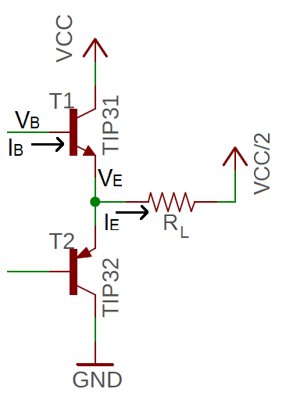

Figure : The output stage of the audio amplifier consists of a pair of emitter followers.

I made the changes going from Figure 1 to Figure 6. These changes are valid and made to simplify the analysis. For example, since this is a small signal analysis (we are looking at changes in values e.g. ΔVB) we will ignore the 100uF capacitor C13 in Figure 6 because the capacitor appears as a short at audio-frequencies. The speaker is rated as an 8Ω load, represented by RL – please use RL in the subsequent analysis. Finally, focus on the labeled NPN transistor, T1, in Figure 6 when answering the following questions.

**Compute the input impedance of the emitter follower - Rief.** You will need to reference Figure 6 during this analysis.

1. What is the relationship between ΔVB and ΔVE?

**ΔVB = ΔVE**

1. Use Ohm’s law to describe the relationship between ΔVE and ΔIE. Call the resistance of the speaker RL.

**ΔVE = ΔIE \*** **RL**

1. Solve the previous equation for ΔIE and replace ΔVE with ΔVB (using the relationship in equation 1)

**ΔIE = ΔVE / RL ΔIE = ΔVB / RL**

1. What is the relationship between ΔIE and ΔIB? Hint, it involves a bad parameter.

**ΔIE = βΔIB**

1. Equate the equations from steps 3 and 4 using ΔIE.

**ΔVB / RL = βΔIB**

1. Solve equation in step 5 for ΔVB/ΔIB, this is the input impedance of the emitter follower. Insert this value into the Rief cell of Table 1.

**Rief = ΔVB / ΔIB = β RL**

**Compute the output impedance of the emitter follower – Roef.** You will need to reference Figure 6 during this analysis.

1. Use Ohm’s law to describe the relationship between ΔVE and ΔIE. Call the resistance of the speaker RL.

**ΔVE = ΔIE * RL**

1. Solve the equation from step 1 for ΔVE/ΔIE, this is the output impedance of the emitter follower. Insert this value into the Roef cell of Table 1.

**Roef = ΔVE / ΔIE = RL**

**Compute the voltage gain of the emitter follower - Aef.** You will need to reference Figure 6 during this analysis.

1. What is the relationship between ΔVB and ΔVE?

**ΔVB = ΔVE**

1. Solve the equation from step 1 for ΔVE/ΔVB, this is the voltage gain of the emitter follower. Insert this value into the Aef cell of Table 1.

**Aef = ΔVE / ΔVB = 1**

**Compute the overall gain of amplifier with no load:**

Since our analysis will break down if we do not have a load resistance, we will model an open circuit output as a 1MΩ resistor as shown in Figure 7. In this analysis assume a value of *β* =100.

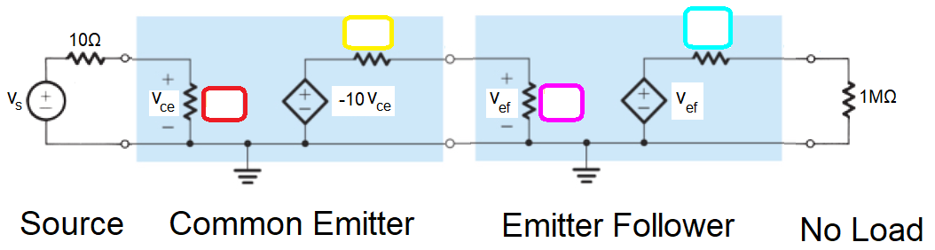

Figure : The Audio amplifier with a very high load resistance that models no load.

1. Fill in the values of the resistors shown in Figure 7.
2. Compute Vce in terms of Vs. Use this to determine the gain Vce/Vs. Assume 20,000 + 10 = 20,0000.

**Vce = Vs*20k/(20k + 10) = Vs Vs/Vce = 1**

1. Compute Vef in terms of Vs. Use this to determine the gain Vef/Vs. Assume 200,000,000 +1,000 = 200,000,000

**Vef = -10*Vce*200M/(200M + 1k) = -10Vce = -10Vs Vef/Vs = -10**

1. Calculate the current delivered to the 1MΩ load. Assume that 1/1,000,000 = 0.

**Iload = -10Vs/2MΩ = 0mA**

**Analysis of amplifier with 8Ω load**

We will model the speaker as an 8Ω resistor as shown in Figure 7. In this analysis assume a value of *β* =100.

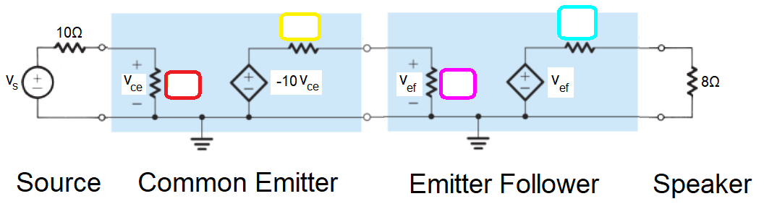

Figure : The Audio amplifier with an 8Ω load that represents a speaker.

1. Fill in the values of the resistors shown in Figure 8. Assume β =100.
2. Compute Vce in terms of Vs. Use this to determine the gain Vce/Vs. Assume 20,000 + 10 = 20,0000.

**Vce = Vs*20k/(20k + 10) = Vs Vce/Vs = 1**

1. Compute Vef in terms of Vs. Use this to determine the gain Vef/Vs.

**Vef = -10*Vce*0.8k/(0.8k + 1k) = -4.4Vce = -4.4*Vs Vef/Vs = -4.4**

1. Calculate the current delivered to the 8Ω load in terms of Vs.

**Iload = -4.4Vs/16Ω = 0.28*Vs/Ω**

# Assembly

This lab document does not contain any information of the assembly process. Please consult the Assembly Guide posted on Canvas for more information.

# Testing the Amplifier Subsystem

Until the pair of potentiometers are adjusted, your amplifier subsystem will not work properly. It would be best to have someone else check your component placement and orientations and check theirs. Then come to lab next week ready to learn how to adjust the potentiometers and get some sound from your amplifier.

# Turn In

Make a record of your response to numbered items below and turn them in a single copy as your team’s solution on Canvas using the instructions posted there. Include the names of both team members at the top of your solutions. Use complete English sentences to introduce what each of the following listed items (below) is and how it was derived.

Hint, use Ctrl+click to follow links. This also works for all the Figures and Tables in these labs.

**Audio Amplifier**

Steps 1 – 3

**Common Emitter Theory**

Steps 1 – 3

**The Vbe Multiplier**

Steps 1 – 12

**Compute the input impedance of the common emitter stage - *Rice*.**

Steps 1 – 6

**Compute the output impedance of the common emitter stage -** *Roce***.**

Steps 1 – 2

**Compute the gain of the common emitter stage - *Ace*.**

Steps 1 – 8

**Compute the input impedance of the emitter follower - Rief.**

Steps 1 – 6

**Compute the output impedance of the emitter follower – Roef.**

Steps 1 – 2

**Compute the voltage gain of the emitter follower - Aef.**

Steps 1 – 2

**Compute the overall gain of amplifier with no load**

Steps 1 – 4

**Compute the overall gain of amplifier with 8Ω load**

Steps 1 – 4

**Complete Table 1**